**Worksheet-2.3**

**Student Name:-** Pushpraj Roy **UID:-** 20BCS9866

**Branch:-** BE- CSE **Section/Group:-** WM_617 “A”

**Subjetct Code:-** 20CSP-317 **Semester:-** 5th

**Subject Name:-** Machine Learning Lab

1. **Aim/Overview of the practical: -**

Implement K-nearest neighbor data sets also known as KNN algorithm

1. **Task to be done/ Which logistics used:-**

To prepare a model with KNN Algorithm

1. **Source Code:-**

|  |
| --- |
| import numpy as np import pandas as pd  import matplotlib.pyplot as plt  from sklearn.datasets import make_blobs from sklearn.neighbors import KNeighborsClassifier from sklearn.model_selection import train_test_split |

X, y = make_blobs(n_samples = 500, n_features = 2, centers = 4,cluster_std = 1.5, ran

dom_state = 4)

|  |
| --- |
| plt.style.use('seaborn') plt.figure(figsize = (10,10))  plt.scatter(X[:,0], X[:,1], c=y, marker= '*',s=100,edgecolors='black') plt.show() |

|  |
| --- |
| X_train, X_test, y_train, y_test = train_test_split(X, y, random_state = 0) knn5 = KNeighborsClassifier(n_neighbors = 5) knn1 = KNeighborsClassifier(n_neighbors=1) knn5.fit(X_train, y_train) knn1.fit(X_train, y_train)  y_pred_5 = knn5.predict(X_test) y_pred_1 = knn1.predict(X_test) |

from sklearn.metrics import accuracy_score print("Accuracy with k=5", accuracy_score(y_test, y_pred_5)*100) print("Accuracy with k=1", accuracy_score(y_test, y_pred_1)*100)

Accuracy with k=5 93.60000000000001

Accuracy with k=1 90.4

plt.figure(figsize = (15,5)) plt.subplot(1,2,1) plt.scatter(X_test[:,0], X_test[:,1], c=y_pred_5, marker= '*', s=100,edgecolors='blac k') plt.title("Predicted values with k=5", fontsize=20)

plt.subplot(1,2,2) plt.scatter(X_test[:,0], X_test[:,1], c=y_pred_1, marker= '*', s=100,edgecolors='blac k') plt.title("Predicted values with k=1", fontsize=20) plt.show()

**3. Result/Output**

Visualize the Dataset

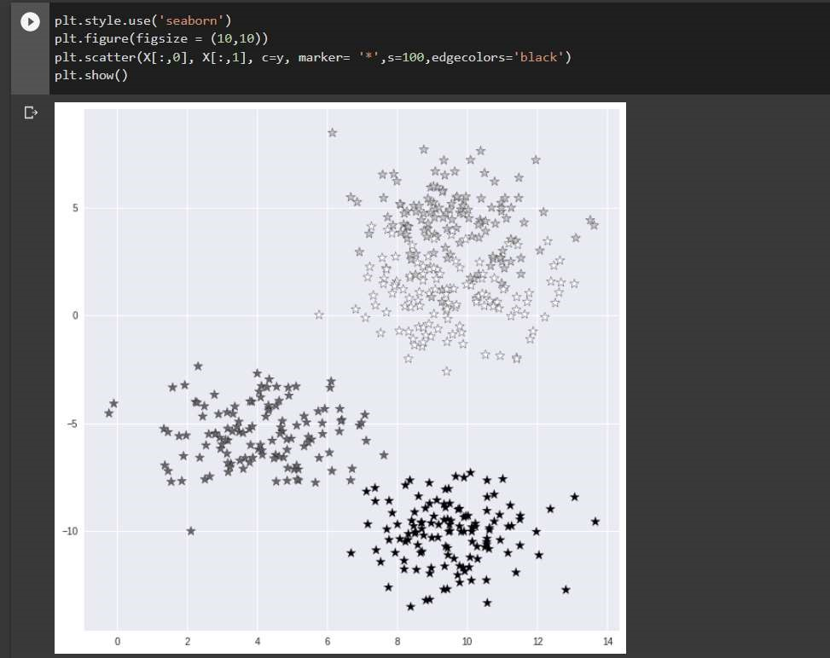

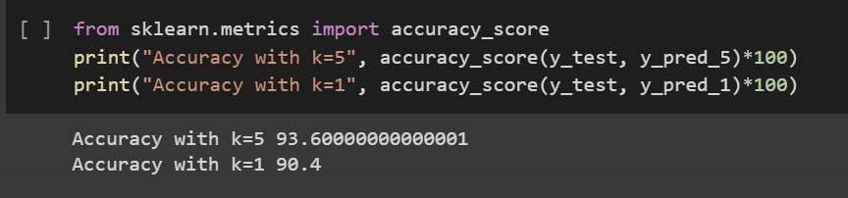

Visualize Predictions

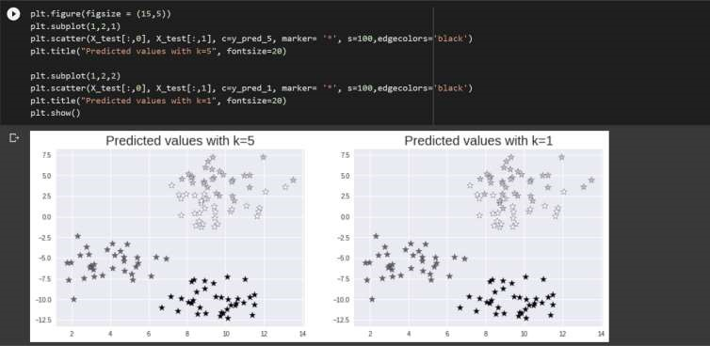

**Learning outcomes (What I have learnt):**

1. Understanding of Exploratory K-nearest neighbor data sets.
2. Able to analyze different K-nearest with the help of python and pandas library.
3. Learning about different library/packages of python.
4. Learning about the different methods, that are needed to analyze the given dataset.
5. Learning of different Machine Learning Functions